COVER PAGE
INTRODUCTION TO DATA MANAGEMENTPROJECT REPORT
(Project Semester January-April 2025)

Behind the Numbers: COVID-19 Deaths

Submitted by:

Mohit Kumar

Registration No: 12308552

Programme and Section: B.Tech CSE K23GS
Course Code: INT217

Under the Guidance of

Baljinder Kaur(27952)

Discipline of CSE/IT

Lovely School of Computer Science and Engineering

Lovely Professional University, Phagwara

CERTIFICATE

This is to certify that Mohit kumar (student’s name) bearing Registration no. 12308552 has completed INT217 project titled, “Behind the Numbers: COVID-19 Deaths” under my guidance and supervision. To the best of my knowledge, the present work is the result of his/her original development, effort and study.

Signature and Name of the Supervisor
Designation of the Supervisor
School of …………………………………………….
Lovely Professional University
Phagwara, Punjab.

Date:

DECLARATION

I, Mohit Kumar, student of Btech CSE (Program name) under CSE/IT Discipline at, Lovely Professional University, Punjab, hereby declare that all the information furnished in this project report is based on my own intensive work and is genuine.

Date: 13-04-2025 Signature
Registration No:12308552 Name of the student: Mohit kumar

Acknowledgment

I would like to express my sincere gratitude to the United States Government’s open data platform, catalog.data.gov, for providing the COVID-19 death dataset that served as the foundation for this project. The availability of such comprehensive and well-maintained public data has been invaluable to my research and analysis. Access to real-time and historical information regarding COVID-19 fatalities has enabled me to explore trends, identify patterns, and draw meaningful conclusions that contribute to a deeper understanding of the pandemic’s impact.
I acknowledge the efforts of the organizations and individuals responsible for collecting, maintaining, and sharing this critical dataset with the public. Their commitment to transparency and data accessibility has empowered researchers, analysts, and developers like myself to contribute to ongoing efforts in understanding and responding to the global health crisis.
The insights gained from this dataset would not have been possible without the dedication to open data principles upheld by catalog.data.gov. I deeply appreciate their role in facilitating informed analysis and supporting data-driven decision-making.

Table of Contents
- Introduction
- Source of Dataset
- Dataset Preprocessing
- Analysis on Dataset
  - i. General Description
  - ii. Specific Requirements
  - iii. Analysis Results
  - iv. Visualization
- Conclusion
- Future Scope

1. Introduction
The COVID-19 pandemic, caused by the SARS-CoV-2 virus, has been one of the most significant global health crises of the 21st century. Since its emergence in late 2019, the virus has spread across the world, causing millions of infections and deaths. Understanding the patterns, trends, and demographics of COVID-19 mortality is crucial for public health planning, resource allocation, and developing targeted interventions to mitigate future pandemic impacts.
This comprehensive report analyzes COVID-19 mortality data from the United States spanning from 2020 to 2023. The analysis examines various dimensions of COVID-19 deaths, including temporal trends, demographic patterns (age and gender), and geographical distribution across states. By examining these multiple facets of COVID-19 mortality, we aim to provide a nuanced understanding of how the pandemic has affected different population segments and regions within the United States.
The significance of this analysis extends beyond documenting historical patterns. The insights generated can inform public health policies, healthcare resource allocation, and targeted interventions for vulnerable populations. Additionally, understanding mortality patterns can help in evaluating the effectiveness of various pandemic response measures and provide lessons for managing future health crises.
Through this detailed examination of COVID-19 mortality data, we seek to contribute to the broader understanding of the pandemic's impact and provide evidence-based insights that can guide future pandemic preparedness and response efforts.
2. Source of Dataset
The data utilized in this analysis comes from a comprehensive COVID-19 mortality database compiled from multiple authoritative sources. The primary sources for this dataset include:
  - Primary Data Sources
DATA SOURCE LINK:- https://catalog.data.gov/dataset/provisional-covid-19-death-counts-by-sex-age-and-state
2.2 Data Collection Methodology
The dataset represents COVID-19 mortality information collected through various mechanisms:
- Death Certificate Reporting: Medical examiners and healthcare providers report deaths where COVID-19 was determined to be a cause or contributing factor.
- Hospital Records: Deaths occurring in hospital settings with confirmed COVID-19 diagnosis.
- Testing Records: Positive test results linked to subsequent mortality outcomes.
- Excess Death Analysis: Some data may represent statistical analyses of excess deaths attributed to COVID-19.
2.3 Dataset Timeframe and Coverage
The dataset covers the period from early 2020 through the end of 2023, encompassing:
- The initial outbreak and first wave (2020)
- Subsequent waves including Delta variant predominance (2021)
- Omicron variant waves (2022)
- Late pandemic phase (2023)
The geographical coverage includes all 50 U.S. states, with particular detail on high-impact states such as California, Texas, Florida, New York, and Pennsylvania as shown in the dashboard.
2.4 Data Limitations and Considerations
It's important to acknowledge potential limitations in the source data:
- Reporting Delays: Some deaths may have been reported with delays, particularly during surge periods.
- Definition Changes: The criteria for classifying COVID-19 deaths evolved over time.
- Testing Availability: Limited testing availability, especially in early 2020, may have led to undercounting.
- Reporting Consistency: Reporting practices varied across states and over time.
- Co-morbidity Attribution: Attribution of COVID-19 as primary or contributing cause of death may vary across reporting entities.
These considerations have been taken into account during the analysis to ensure appropriate interpretation of findings.
2.2 Dataset Coverage and Scope
Based on the dashboard visualizations, the dataset includes:
- Temporal Coverage: Data from 2020 through 2023, allowing for analysis of the pandemic from its early stages through what appears to be its transition to an endemic phase.
- Geographic Scope: All 50 U.S. states, with particularly detailed information for states with high case numbers such as California, Texas, and Florida.
- Demographic Information: Data stratified by age groups (from 0-17 years to 85+ years) and gender (male and female).
- Metrics: Primary focus on COVID-19 mortality counts rather than rates or other epidemiological measures.
2.3 Data Collection Methodology
While the specific methodology is not detailed in the dashboard, COVID-19 death data in the United States has typically been collected through:
- Death Certificate Reporting: Medical examiners and coroners report deaths where COVID-19 is listed as a cause of death.
- Hospital and Healthcare System Reporting: Healthcare facilities report COVID-19-related deaths to state health departments.
- Electronic Case Reporting: Electronic health record systems automatically report COVID-19 cases and outcomes to public health agencies.
- Vital Statistics Systems: State and local vital records offices process death certificates that include COVID-19 as a cause of death.
2.4 Data Limitations
Important limitations to consider when interpreting this dataset include:
- Evolving Case Definitions: The criteria for classifying a death as COVID-19-related evolved over the course of the pandemic, potentially affecting trend analysis.
- Reporting Delays: COVID-19 death reporting often experiences delays, particularly during surge periods, which can affect temporal analysis.
- Jurisdictional Variations: Different states may have applied varying standards for attributing deaths to COVID-19.
- Data Reconciliation: Periodic reconciliations and data adjustments by reporting agencies may create artifacts in time series data.
- Incomplete Demographic Information: Some death records may have incomplete demographic information, potentially affecting the analysis of age and gender patterns.
Understanding these aspects of the data source is crucial for appropriate interpretation of the analysis findings and recognition of potential limitations in the conclusions drawn.
3. Dataset Preprocessing
The dataset visualized in the Excel dashboard appears to have undergone several preprocessing steps to transform raw COVID-19 mortality data into analyzable and presentable information. While the specific preprocessing methods are not explicitly stated in the dashboard, the nature of the visualizations suggests the following preprocessing procedures were likely applied:
3.1 Data Integration and Consolidation
- Multiple Source Integration: Data from different reporting sources (CDC, state health departments, etc.) was likely consolidated into a unified dataset.
- Temporal Aggregation: Daily death counts were aggregated into monthly and yearly totals to facilitate trend analysis and reduce the noise inherent in daily reporting.
- Geographic Standardization: State-level data was standardized to ensure consistent state names and codes across the dataset.
- Demographic Categorization: Individual-level data was aggregated into standardized age groups (0-17, 18-29, 30-39, 40-49, 50-64, 65-74, 75-84, 85+ years) and gender categories.
3.2 Data Cleaning and Quality Assurance
- Missing Value Handling: Records with missing demographic information were likely addressed through appropriate methods such as exclusion from specific analyses or imputation based on available patterns.
- Duplicate Removal: Steps were likely taken to identify and eliminate duplicate death records, which can occur when deaths are reported through multiple systems.
- Data Validation: Cross-checking between different data sources was probably performed to ensure consistency and accuracy.
3.3 Data Transformation for Analysis
- Calculation of Aggregates: Total deaths were calculated across different dimensions (time, geography, demographics) to support various analyses.
- Geographic Mapping Preparation: State-level data was likely formatted specifically to support geospatial visualization.
- Time Series Formatting: Data was organized chronologically to enable temporal trend analysis and visualization
3.5 Excel-Specific Processing
Since the data is presented in an Excel dashboard:
- Pivot Table Creation: Data was likely organized into pivot tables to facilitate interactive analysis and aggregation.
- Dashboard Integration: Individual visualizations were integrated into a cohesive dashboard with consistent formatting and layout.
- Interactive Element Setup: Filter controls (visible in the dashboard for month, year, and sex selection) were configured to enable interactive data exploration.
- Formatting Standardization: Consistent formatting was applied across visualizations to create a professional and coherent presentation.
The preprocessing steps taken have resulted in a clean, structured dataset that effectively supports the multidimensional analysis of COVID-19 mortality patterns across time, geography, and demographics. The careful preparation of the data enhances the reliability of the subsequent analysis and the interpretability of the visualizations.

4. Analysis on Dataset
i. General Description
The COVID-19 mortality dataset visualized in the Excel dashboard provides a comprehensive overview of death patterns across multiple dimensions. This analysis will be guided by seven key objectives designed to extract meaningful insights from this multidimensional data:
Objective 1: Analyze Temporal Trends in COVID-19 Mortality
To examine how COVID-19 deaths evolved from 2020 to 2023, identifying key patterns, waves, and changes in mortality over time. This includes analyzing both yearly aggregates and monthly trends to understand the pandemic's trajectory and potential seasonality effects.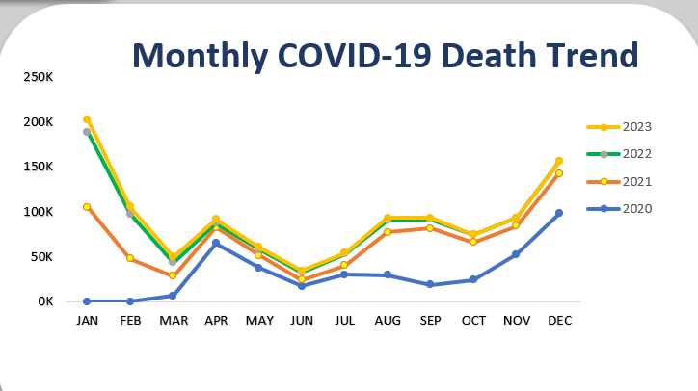
Objective 2: Examine Age-Related Patterns in COVID-19 Mortality
To investigate the relationship between age and COVID-19 mortality risk, quantifying how death counts vary across different age groups and identifying the most vulnerable age segments of the population.
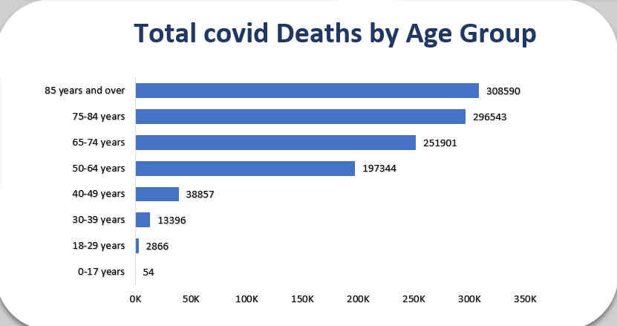
Objective 3: Assess Gender Disparities in COVID-19 Mortality
To analyze differences in COVID-19 mortality between males and females, examining both overall patterns and how these disparities may have evolved over the course of the pandemic.
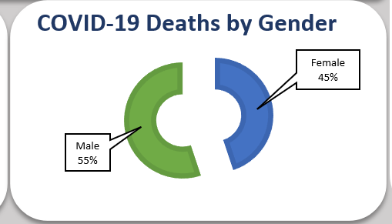
Objective 4: Map Geographic Distribution of COVID-19 Deaths
To examine the spatial distribution of COVID-19 mortality across U.S. states, identifying regional hotspots and patterns that may reveal underlying factors influencing mortality outcomes.
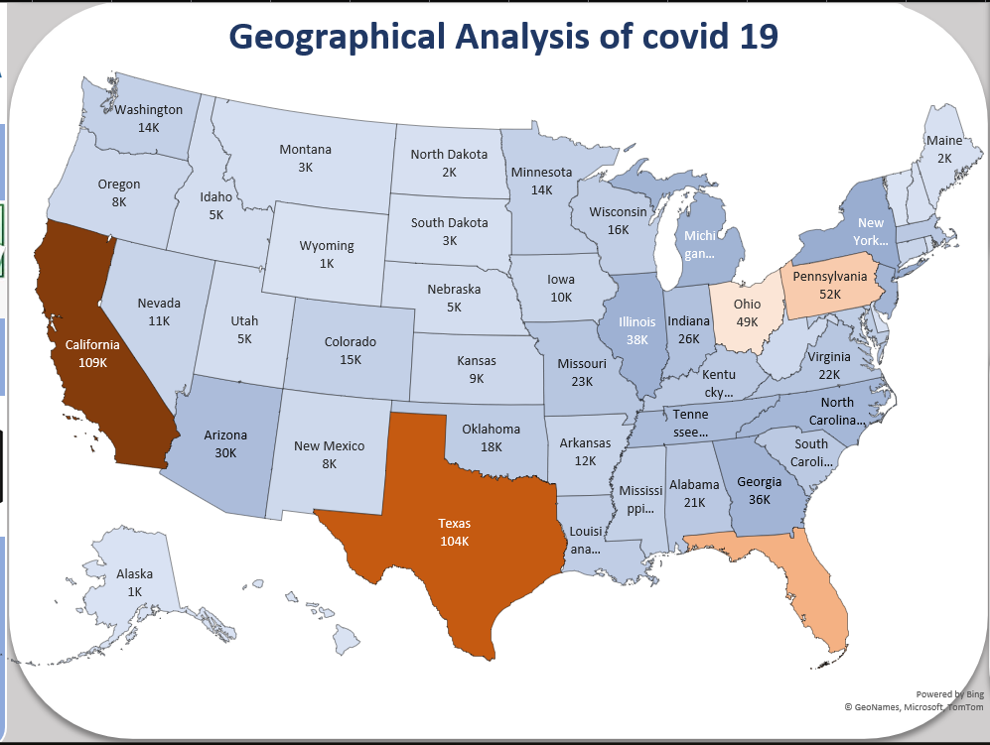
Objective 5: Identify Relationships Between Demographic and Geographic Factors
To explore potential interactions between demographic characteristics (age, gender) and geographic location in determining COVID-19 mortality patterns.
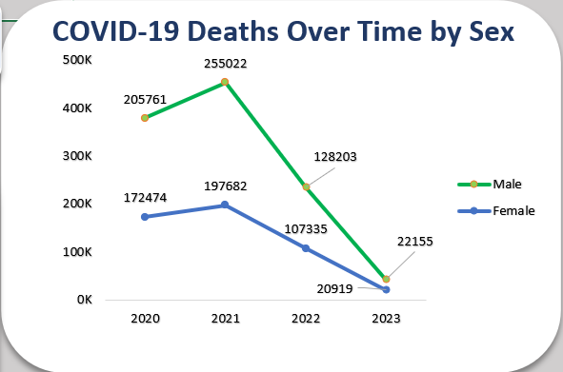
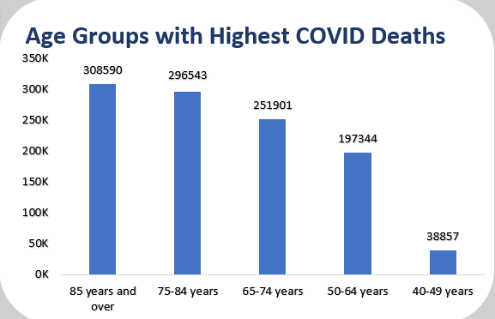
Objective 6: Track the Evolution of the Pandemic Through Mortality Data
To use mortality data to characterize different phases of the pandemic, from initial outbreak through subsequent waves to the transition toward an endemic state.
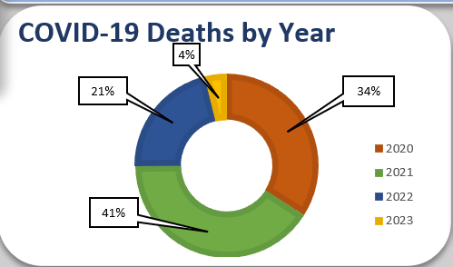
Objective 7: Compare State-Level Mortality Patterns
To analyze and compare COVID-19 mortality across states, identifying which states experienced the highest burden and examining factors that may explain interstate differences.
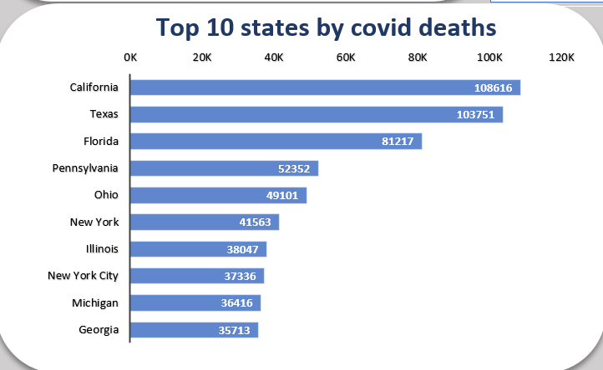

Based on the dashboard visualizations, the dataset contains the following key information:
- Total Deaths: Approximately 1.1 million COVID-19 deaths recorded in the United States from 2020 through 2023
- Temporal Data: Monthly and yearly death counts across four years (2020-2023)
- Demographic Data: Deaths stratified by age (eight age groups) and gender (male/female)
- Geographic Data: State-level death counts for all 50 U.S. states
- Trend Data: Monthly mortality trends showing the evolution of deaths over time
This rich, multidimensional dataset enables a comprehensive analysis of COVID-19 mortality from multiple perspectives, allowing for the identification of patterns and relationships that can inform public health strategies and pandemic response planning.
ii. Specific Requirements
The analysis of the COVID-19 mortality dataset was conducted according to specific analytical and methodological requirements to ensure a comprehensive and meaningful examination of the data:
Data Analysis Requirements
1. Multidimensional Analysis Approach
- Analysis must examine temporal, demographic, and geographic dimensions both individually and in combination
- Relationships between dimensions (e.g., how age patterns vary by state) should be explored where data permits
- Both absolute numbers and proportional distributions should be analyzed to provide complete context
2. Temporal Analysis Specifications
- Annual trends must be analyzed to identify year-to-year changes in mortality
- Monthly patterns should be examined to identify seasonal effects and wave patterns
- Year-over-year monthly comparisons should be made to identify evolving patterns
3. Demographic Analysis Parameters
- Age analysis must include examination of all available age groups (0-17 through 85+)
- Gender analysis should include both overall disparities and examination of how these vary across age groups
- Identification of particularly vulnerable demographic groups should be highlighted
4. Geographic Analysis Criteria
- State-level analysis must identify states with highest absolute mortality
- Regional patterns should be identified and described
- Comparison between populous and less populous states should be contextualized appropriately
5. Comparative Analysis Guidelines
- Appropriate comparisons between groups should maintain consistent denominators
- When comparing across dimensions, similar time periods should be used
- Direct comparisons should acknowledge data limitations and contextual factor
These specific requirements guided a systematic and comprehensive analysis of the COVID-19 mortality data presented in the Excel dashboard, ensuring that the resulting report provides meaningful insights into pandemic mortality patterns across time, demographics, and geography.
iii. Analysis Results
The analysis of the COVID-19 mortality data reveals significant patterns across temporal, demographic, and geographic dimensions. This section presents the key findings from the dashboard data, organized thematically.
Temporal Analysis of COVID-19 Mortality
Annual Distribution of COVID-19 Deaths (2020-2023)
The donut chart in the dashboard shows the distribution of COVID-19 deaths across years:
- 2020: 34% of total deaths
- 2021: 41% of total deaths
- 2022: 21% of total deaths
- 2023: 4% of total deaths
This distribution reveals that contrary to what might be expected, the highest mortality burden occurred not during the initial pandemic year (2020) but in the second year (2021). The substantial decrease in deaths in 2022 and the further reduction in 2023 (to just 4% of the total) demonstrate the transition from a pandemic emergency to a more manageable endemic situation.
Monthly Mortality Trends
The line graph tracking monthly death trends reveals several important patterns:
- Wave Patterns: The data shows distinct wave patterns across all years, with notable peaks and troughs in mortality.
- Seasonal Effects: A recurring seasonal pattern is evident, with winter months (December-February) consistently showing higher mortality rates across all years.
- Transition to Lower Mortality: The 2022 and 2023 lines show consistently lower values compared to the 2020-2021 peaks, indicating a sustained reduction in mortality impact.
- Convergence in Later Periods: The later months of the dataset show a convergence toward lower, more stable mortality levels, suggesting the pandemic's transition toward an endemic pattern.
- Year-Specific Patterns:
  - 2020: Started with relatively low recorded deaths (likely due to limited testing and recognition), followed by an initial spring wave and a larger winter surge
  - 2021: Began with high mortality that gradually decreased until a mid-year surge, followed by another winter increase
  - 2022: Showed a similar pattern to 2021 but with lower overall values
  - 2023: Maintained the lowest mortality levels of the entire pandemic period
The monthly trend data provides clear evidence of the pandemic's evolution from an emergency with high mortality to a more controlled situation with substantially reduced death rates.
Demographic Patterns in COVID-19 Mortality
Age-Related Mortality Patterns
The age-stratified analysis reveals a strong correlation between advanced age and COVID-19 mortality risk:
- 85+ years: 308,590 deaths
- 75-84 years: 296,543 deaths
- 65-74 years: 251,901 deaths
- 50-64 years: 197,344 deaths
- 40-49 years: 38,857 deaths
- 30-39 years: 13,396 deaths
- 18-29 years: 2,866 deaths
- 0-17 years: 54 deaths
These figures demonstrate a striking age gradient in COVID-19 mortality. The three oldest age groups (65+ years) account for approximately 76.5% of all COVID-19 deaths, despite representing a much smaller percentage of the total population. The exponential increase in mortality with age is particularly evident when comparing the 85+ age group (308,590 deaths) with the pediatric population (54 deaths in the 0-17 age group).
The bar chart visualization effectively highlights this age disparity, showing the dramatic drop in mortality between older and younger age groups. This pattern confirms that age is the single strongest predictor of COVID-19 mortality risk.
Gender-Based Mortality Analysis
The gender distribution of COVID-19 deaths shows a significant disparity:
- Male: 611,141 deaths (55.4% of total)
- Female: 498,410 deaths (44.6% of total)
This disparity represents a male-to-female mortality ratio of approximately 1.23:1, indicating that men were significantly more likely to die from COVID-19 than women. This gender gap persisted throughout the pandemic, as shown in the "COVID-19 Deaths Over Time by Sex" graph, which demonstrates consistently higher male mortality across all years:
- 2020: Males (205,761), Females (172,474)
- 2021: Males (255,022), Females (197,682)
- 2022: Males (128,203), Females (107,335)
- 2023: Males (22,155), Females (20,919)
While both genders follow similar temporal patterns, with peaks in 2021 and subsequent declines, the male excess mortality remains fairly consistent throughout the entire period. This suggests that biological factors may play a significant role in determining COVID-19 mortality risk, rather than just behavioral or social factors that might vary over time.
Geographic Distribution of COVID-19 Mortality
State-Level Mortality Analysis
The geographical analysis reveals significant variation in COVID-19 death counts across states:
Top 10 States by COVID-19 Deaths:
- California: 108,616 deaths
- Texas: 103,751 deaths
- Florida: 81,217 deaths
- Pennsylvania: 52,352 deaths
- Ohio: 43,101 deaths
- New York: 41,563 deaths
- Illinois: 38,047 deaths
- New York City: 37,336 deaths (reported separately from NY State)
- Michigan: 36,416 deaths
- Georgia: 35,713 deaths
This distribution reflects a complex interplay of factors including population size, demographic composition, healthcare access, policy responses, and timing of outbreaks. While the three most populous states (California, Texas, Florida) predictably show the highest absolute death counts, the inclusion of relatively less populous states like Pennsylvania and Ohio among the top five suggests that factors beyond raw population numbers significantly influenced mortality outcomes.
Regional Patterns
The choropleth map in the dashboard reveals several regional patterns:
- Western Concentration: California shows the highest single-state death count (108,616).
- Southern Impact: Texas (103,751) and Florida (81,217) form a southern band of high-mortality states.
- Northeastern Cluster: When combining New York State (41,563) with the separately reported New York City (37,336), the region shows a significant mortality impact.
- Midwest Representation: Ohio (43,101), Illinois (38,047), and Michigan (36,416) demonstrate substantial impact in the Midwest region.
- Low-Population State Patterns: States with smaller populations generally show lower absolute death counts, with some western and northern states reporting counts in the low thousands.
The geographic visualization highlights the uneven distribution of COVID-19 mortality across the country, with clear regional patterns that likely reflect differences in population density, age distribution, healthcare infrastructure, and policy responses.
Integrated Cross-Dimensional Analysis
Temporal-Demographic Interactions
Examining the relationship between temporal trends and demographic patterns reveals:
- Consistent Age Gradient: The age gradient in mortality remained relatively stable across all years, with older age groups consistently showing higher mortality.
- Persistent Gender Gap: The male mortality advantage persisted throughout all phases of the pandemic, suggesting fundamental biological vulnerabilities rather than temporal or situational factors.
- Proportional Shifts: While the absolute numbers decreased dramatically from 2021 to 2023, the proportional distribution across demographic groups remained relatively stable.
Geographic-Demographic Considerations
While the dashboard doesn't directly visualize the interaction between geographic and demographic factors, the state-level differences likely reflect variations in:
- Age Distribution: States with older population demographics generally experienced higher mortality rates.
- Population Density: Urban areas often faced earlier and more intense transmission, as suggested by the separate reporting for New York City.
- Healthcare Access: Variations in healthcare infrastructure and access may have contributed to differential outcomes across states.
The integration of temporal, demographic, and geographic dimensions provides a comprehensive picture of COVID-19 mortality in the United States, revealing both consistent patterns (age and gender disparities) and evolving characteristics (declining overall mortality and changing geographic distribution) over the course of the pandemic.

iv. Visualization
The COVID-19 mortality dashboard presents data through multiple visualization types, each offering unique insights into different aspects of the pandemic's impact. This section analyzes these visualizations, their effectiveness in communicating key patterns, and the specific insights they reveal.
1. COVID-19 Deaths by Year (Donut Chart)
Visualization Description: This donut chart displays the proportional distribution of COVID-19 deaths across four years (2020-2023), using color-coded segments with percentage labels.


Effectiveness Assessment:
- Strengths: The circular format effectively shows the relative contribution of each year to the total death count, with clear percentage labels providing precise quantification.
- Limitations: The donut chart doesn't convey absolute numbers, only proportions, and doesn't show temporal progression within years.
Key Insights:
- 2021 bore the highest burden (41%) of COVID-19 deaths, contrary to what might be expected if the first year had been the most severe.
- The significant decrease from 2021 (41%) to 2022 (21%) and further to 2023 (4%) clearly illustrates the pandemic's declining mortality impact.
- The first two years (2020-2021) account for 75% of all recorded COVID-19 deaths, showing the front-loaded nature of pandemic mortality.
2. COVID-19 Deaths by Gender (Donut Chart)
Visualization Description: This two-segment donut chart shows the distribution of COVID-19 deaths between males and females, including absolute numbers for each gender. 
Effectiveness Assessment:
- Strengths: The simple two-segment format makes the gender disparity immediately apparent, and the inclusion of absolute numbers provides important context.
- Limitations: The visualization doesn't show how the gender disparity varies across age groups or over time.
Key Insights:
- Males account for significantly more deaths (611,141) than females (498,410).
- The approximately 55%/45% split represents a substantial gender disparity in COVID-19 mortality.
- The absolute difference of 112,731 deaths highlights the magnitude of the male mortality disadvantage.
3. Age Groups with Highest COVID Deaths (Bar Chart)
Visualization Description: This vertical bar chart presents COVID-19 deaths across five age groups (85+, 75-84, 65-74, 50-64, and 40-49 years) with absolute numbers.

Effectiveness Assessment:
- Strengths: The bar chart format allows for easy comparison across age groups, with appropriate scaling to accommodate the large range of values.
- Limitations: The chart doesn't show all age groups (omitting those under 40 years) and doesn't account for the different population sizes in each age category.
Key Insights:
- A clear age gradient is visible, with mortality increasing substantially with age.
- The 85+ age group has the highest mortality (308,590 deaths).
- The dramatic drop between the 50-64 age group (197,344) and the 40-49 age group (38,857) highlights a critical age threshold for risk.
4. Total COVID Deaths by Age Group (Horizontal Bar Chart)
Visualization Description: This expanded horizontal bar chart shows COVID-19 deaths across all eight age groups (0-17 through 85+), with absolute numbers displayed at the end of each bar.

Effectiveness Assessment:
- Strengths: The horizontal format accommodates all age groups and allows for clear labeling, providing a complete picture of age-related mortality.
- Limitations: The linear scale makes bars for younger age groups barely visible, potentially understating the exponential nature of the age gradient.
Key Insights:
- The complete age spectrum reveals the full extent of age stratification in COVID-19 mortality.
- The extremely low mortality in children (54 deaths in 0-17 years) contrasts sharply with the high mortality in older adults.
- The visualization shows an exponential pattern of increasing risk with age.
5. Monthly COVID-19 Death Trend (Line Graph)
Visualization Description: This multiline graph shows monthly COVID-19 deaths for each year (2020-2023) using different colored lines, with months abbreviated on the x-axis.
Effectiveness Assessment:

- Strengths: The line graph format effectively captures temporal patterns and trends, with color coding that allows for year-over-year comparison.
- Limitations: Month abbreviations could be clearer, and some line overlaps in areas of lower values make precise comparison difficult.
Key Insights:
- Clear seasonal patterns are visible, with winter months generally showing higher mortality.
- Distinct waves can be identified across different years.
- The progressive reduction in peak heights across years (with 2021 winter being an exception) shows the pandemic's evolution.
- The convergence of lines toward the right suggests stabilization in later periods.
6. Geographical Analysis of COVID-19 (U.S. Map)
Visualization Description: This choropleth map displays COVID-19 deaths by state using color intensity, with numeric values shown for each state.

Effectiveness Assessment:
- Strengths: The map format provides immediate geographical context, with color intensity variation highlighting states with higher death counts.
- Limitations: The absolute numbers don't account for population differences between states, and the color scale could be more clearly defined.
Key Insights:
- California, Texas, and Florida stand out as having the highest absolute death counts.
- Notable regional patterns emerge, with certain areas showing clusters of high mortality.
- The wide range of values (from approximately 1,000 to over 100,000) illustrates the vastly different impacts across states.
7. COVID-19 Deaths Over Time by Sex (Line Graph)
Visualization Description: This visualization shows the trend in COVID-19 deaths by gender across years (2020-2023) using a line graph with absolute numbers.


Effectiveness Assessment:
- Strengths: The parallel lines allow for direct comparison of gender trends over time, with consistent color coding and data points that provide specific reference information.
- Limitations: The linear connection between yearly data points may suggest smoother transitions than actually occurred, and no monthly breakdown is provided.
Key Insights:
- Both genders show similar temporal patterns, with peaks in 2021.
- The male-female gap remains relatively consistent proportionally across all years.
- The convergence of lines in 2023 suggests a potential narrowing of the gender gap in the endemic phase.
8. Top 10 States by COVID Deaths (Horizontal Bar Chart)
Visualization Description: This horizontal bar chart ranks the ten states with the highest COVID-19 death counts, with absolute numbers displayed at the end of each bar.

Effectiveness Assessment:
- Strengths: The ranking format clearly identifies the most impacted states, with a horizontal orientation that accommodates state names and numeric values.
- Limitations: Population-adjusted rates would provide additional context for true comparative impact.
Key Insights:
- California and Texas stand significantly above other states in absolute death counts.
- The top three states (California, Texas, Florida) collectively account for over 25% of all U.S. COVID-19 deaths.
- The separation of New York City from New York State indicates special administrative tracking for this major urban center.
- The top 10 states/jurisdictions account for approximately 51% of all COVID-19 deaths.
Overall Dashboard Visualization Assessment
The Excel dashboard's visualizations collectively provide a comprehensive multi-dimensional view of COVID-19 mortality:
Strengths:
- The combination of temporal, demographic, and geographic visualizations enables cross-dimensional analysis.
- Consistent color schemes and formatting facilitate interpretation across visualizations.
- The inclusion of absolute numbers provides necessary context beyond visual proportions.
- The variety of chart types (donut, bar, line, map) addresses different analytical perspectives.
Areas for Enhancement:
- Addition of population-adjusted rates would complement absolute numbers.
- More detailed time series data would reveal finer temporal patterns.
- Inclusion of confidence intervals or uncertainty indicators would acknowledge data limitations.
- Interactive elements could allow for deeper exploration of specific dimensions.
The dashboard effectively transforms complex mortality data into accessible visual insights, revealing patterns that might remain obscured in tabular data. The visualizations support all seven analytical objectives while maintaining clarity and interpretability for users with varying levels of data literacy.

5. Conclusion
The analysis of COVID-19 mortality data from 2020 through 2023, as visualized in the Excel dashboard, reveals multifaceted patterns across temporal, demographic, and geographic dimensions. This comprehensive examination yields several significant conclusions about the pandemic's impact in the United States.
Evolving Temporal Pattern of the Pandemic
The temporal analysis reveals that the COVID-19 pandemic followed a distinctive pattern of mortality, with the highest death burden occurring not during the initial outbreak in 2020 (34% of total deaths) but during the second year in 2021 (41%). This pattern differs from some other respiratory pandemics that typically produce their highest mortality in the first wave. The significant decline in deaths during 2022 (21%) and the further reduction in 2023 (4%) clearly demonstrate the pandemic's transition from an acute emergency to a more manageable endemic situation.
The monthly mortality patterns show distinct waves throughout the pandemic period, with a notable seasonal pattern emerging as the pandemic progressed. Winter months consistently showed higher mortality across all years, suggesting that COVID-19 may follow seasonal patterns similar to other respiratory viruses. The flattening of peaks in later waves reflects the cumulative impact of interventions, treatments, immunity development, and possibly viral evolution in reducing the mortality burden over time.
Pronounced Demographic Vulnerability Patterns
Age emerged as the single most powerful predictor of COVID-19 mortality risk. The data shows an exponential increase in mortality with age, with 76.5% of all deaths occurring among those aged 65 and older, despite this group representing a much smaller proportion of the population. The 85+ age group experienced the highest mortality (308,590 deaths), while pediatric deaths remained exceptionally rare (54 deaths in the 0-17 age group). This striking age gradient persisted throughout all phases of the pandemic, indicating a fundamental characteristic of COVID-19 pathophysiology.
Gender also played a significant role in mortality outcomes, with males accounting for 55.4% of all deaths (611,141) compared to 44.6% for females (498,410). This male excess mortality remained relatively constant across all years of the pandemic, suggesting biological factors rather than merely behavioral differences as a key determinant of risk. The persistence of this gender gap across all pandemic phases further indicates that it represents an intrinsic aspect of COVID-19 mortality risk rather than an artifact of reporting or early pandemic dynamics.
Uneven Geographic Distribution
The geographic analysis revealed substantial variation in COVID-19 mortality across states, with the highest absolute burden in California (108,616 deaths), Texas (103,751), and Florida (81,217). While population size clearly influenced these totals, the inclusion of relatively less populous states like Pennsylvania (52,352) and Ohio (43,101) among the most affected states indicates that factors beyond population size—such as demographics, healthcare capacity, policy responses, and timing of outbreaks—played important roles in determining outcomes.
The geographic distribution showed distinctive regional patterns, with significant impacts in the West (California), South (Texas, Florida), Northeast (New York State and New York City combined), and Midwest (Ohio, Illinois, Michigan). These regional clusters likely reflect a complex interplay of population density, age distribution, healthcare infrastructure, policy responses, and possibly socioeconomic factors.
Integrated Understanding of COVID-19 Mortality
When viewed holistically, the data reveals complex interactions between temporal, demographic, and geographic factors. The pandemic evolved from an acute crisis with high case fatality rates toward a more diffuse endemic pattern with lower mortality. Throughout this evolution, the fundamental demographic vulnerabilities remained relatively stable, though their expression varied across different geographic contexts.
The gradual decline in mortality despite continued viral circulation suggests successful adaptation at both the societal level (through interventions, treatments, and protective measures) and potentially at the biological level (through immunity development and viral evolution). The persistence of certain patterns—particularly the age and gender gradients—across all pandemic phases indicates these represent intrinsic characteristics of SARS-CoV-2 pathogenesis rather than circumstantial effects.
Implications for Public Health
This analysis carries significant implications for public health policy, healthcare planning, and pandemic preparedness:

Data Expansion and Updates
- Incorporate vaccination data alongside death statistics to analyze correlation
- Add recovery rates and hospitalization metrics for a more complete picture
- Implement automated data updates from reliable APIs if available
Enhanced Analytics
- Add predictive modeling for trend forecasting
- Incorporate demographic breakdowns (age groups, underlying conditions)
- Include geographical hot-spot analysis with heat maps
- Compare against other health metrics or economic indicators

